**Student Name, ID**: Sanad Abdelrahman Alawi, 21110042

**Instructor**:Doctor Sinan Kamal

**Teaching Assistant**: Engineer Asma AlFakhore

Before starting with the report, I want to extend my thanks and appreciations for **Doctor Sinan Kamal** for His Amazing Performance throughout the semester lectures that helped me write this report Successfully.

Before starting with the report, I want to extend my thanks and appreciations for **Doctor Balqis Aldabaibeh** for Her Amazing Performance throughout the semester lectures that helped me write this report Successfully.

-----------------------------------------------------------------------------------------

**Course**: Data Visualization – Final Project

**Section**: 1

**Date**: 1 – 20 – 2024, Monday

Course Assignment brief and Guidance

# Table of Contents

Table of Contents 4

What is Data Visualization? 4

Our Scenario 6

Q1. Discuss, assess the value of the collected data and insights to the Sales Managers, to the agents, and to Company executives. 7

Q2. Propose clear questions and discussion points needed for elicitation sessions with: Sales Manager, Shop Manager, and Sales Performance Manager. 11

Q3. Explain, asses, and evaluate data set and provide recommendations to optimize provided datasets. 15

Q4. Provide clear data abstraction and task abstraction summarization that you will rely on to design sales dashboard and describe how Data Visualization nested model had been applied to your dashboards and what can be optimized. 19

Q5. Design sales dashboard using Power BI to build a clear and informative dashboard. Your dashboard should clearly show summary statistics about the major variables and help the audience quickly understand the sales landscape. 25

Q6. Explain how the dashboards are utilizing the human perceptual and cognitive system. 34

Q7. Explain the value of having the right selection of the visual design in your dashboard. 41

Q8. Clarify the methods used in selecting and designing your visualization design (chart type, Marks and Channels, Visual encoding techniques). 46

References 49

# What is Data Visualization?

Firstly, and first of all, before starting with anything in our report document or before answering any of the given questions, let us discuss (and talk about) what is **data visualization**.

In very simple words, **data visualization** is both an art and science (though it leans more towards art) of creating graphical representations of information and data. This involves the use of visual elements such as: **charts**, **graphs**, **scatter plots**, **boxplots**, **maps**, and **dashboards**. The purpose of data visualization is to transform (and change) raw data into a visual context, making it 🡪 (1) easier to understand, (2) interpret, and (3) analyze complex – and sophisticated – datasets.

To create a good visualization – one that communicates information effectively – there are four key elements that must be present. These four elements, which are also reflected in the diagram below are:

1. Information 🡪 Ensuring the data being visualized is accurate, relevant, and consistent. This is the foundation for any visualization.
2. Story 🡪 A good visualization tells a story. It provides context and meaning to the data by connecting the dots and engaging the audience.
3. Goal 🡪 Every visualization must serve a purpose. Whether it’s for decision-making, highlighting patterns, or understanding trends, the goal defines the visualization’s intent.
4. Visual Form 🡪 The way the data is presented matters. Choosing the right **marks and channels**, as well as using appropriate colors and design elements, ensures that the visualization is not only functional; but also aesthetically pleasing.

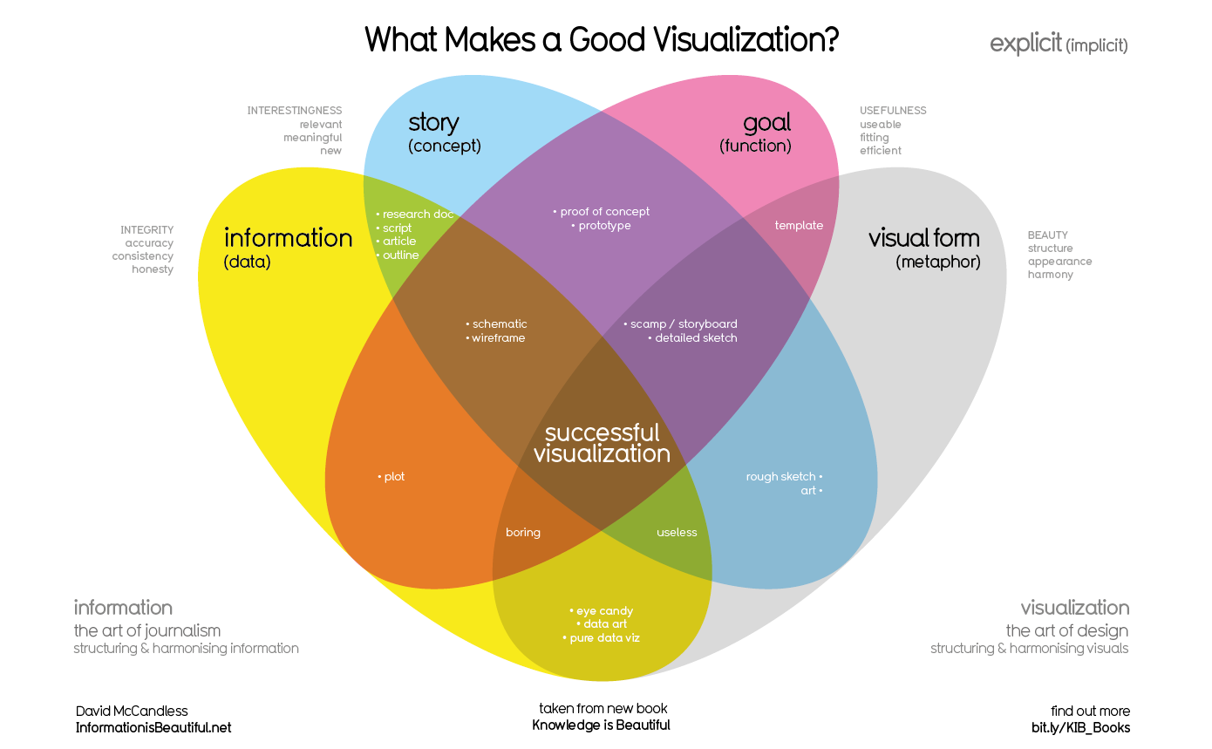

(Reference for the Image Above 🡪 [(4) The four key elements of good data visualisation | LinkedIn](https://www.linkedin.com/pulse/four-key-elements-good-data-visualisation-sean-mcdougall/)) (*(4) The four key elements of good data visualisation | LinkedIn*, 2021)

# Our Scenario

The scenario we are working with in this report assumes (and pretends) that we are part of a **data analytics start-up company**, and I am a **data visualizer** in that company. Our client, a telecom company named **Cheetah Telecom**, has approached us for assistance (and help). Their logo is shown below:

Cheetah Telecom is a cutting-edge telecom company named after the cheetah, symbolizing its commitment to delivering **fast internet connections** and **ground-breaking speeds**, much like the agility and speed of the animal itself. The company aims to stay ahead in the competitive telecom industry by leveraging data-driven insights to enhance (and improve) its sales performance.

To achieve this goal, **Cheetah Telecom** has tasked us with creating a comprehensive **sales dashboard**. This dashboard is intended to provide key sales insights, analyze performance trends, and evaluate sales activities across multiple channels and regions. It will support decision-making at the: (1) **operational**, (2) **tactical**, and (3) **strategic** levels. The datasets for this project originate from various fields and departments within Cheetah Telecom, and our role involves exploring, analyzing, and visualizing this data to generate (and produce) actionable insights.

In this report, we will document the process of designing and developing the dashboards, along with the insights and recommendations derived from the data analysis.

# Q1. Discuss, assess the value of the collected data and insights to the Sales Managers, to the agents, and to Company executives.

The collected data that we have consists of four given tables, each serving a unique purpose in understanding and analyzing sales performance:

***Table 1: Dataset June_Dec 2024***

This table contains transactional data, including:

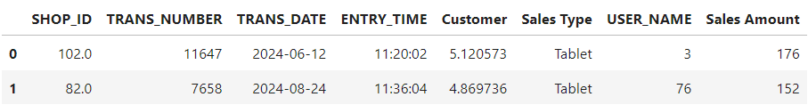

* SHOP_ID 🡪 Identifies shops uniquely and links to the Shops table.
* TRANS_NUMBER 🡪 Unique identifier for each transaction.
* TRANS_DATE and ENTRY_TIME 🡪 Provide the date and time of transactions.
* Sales Type 🡪 Specifies the type of sales (e.g., Mobile Line, Tablet, Internet Line).
* Sales Amount 🡪 Indicates the monetary – money value of transactions.
* USER_NAME 🡪 Represents sales agents involved in each transaction.
* Customer 🡪 Encodes unique customer IDs.

The table covers **three months (June, July, and August 2024)**, with **405,479 rows** and **8 columns**, making it a medium-sized dataset suitable for efficient processing and analysis.



***Table 2: Shops Table***

This table contains shop-specific information, including:

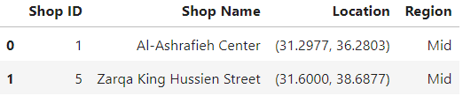

* Shop Name 🡪 Name of the shop.
* Region 🡪 Specifies the geographic location (e.g., Mid, North, South).
* Location 🡪 Includes latitude and longitude for mapping purposes.
* Shop ID 🡪 Unique identifier for each shop.

This table contains **73 rows** and **4 columns**, providing comprehensive information about shop locations and regional distribution.



***Table 3: Transaction Average Time Table***

This table contains the average transaction time for different sales types (e.g., Add Commitment, Corporate Line). It helps in understanding how long different sales types take on average, providing insights into efficiency.

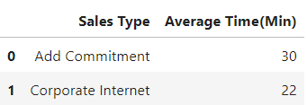

The table has **8 rows** and **2 columns**, making it a small but valuable dataset for identifying time-intensive processes.



***Table 4: Metadata Table***

This table describes and defines columns across the entire dataset. It serves as a reference guide to ensure proper understanding and interpretation of the data.

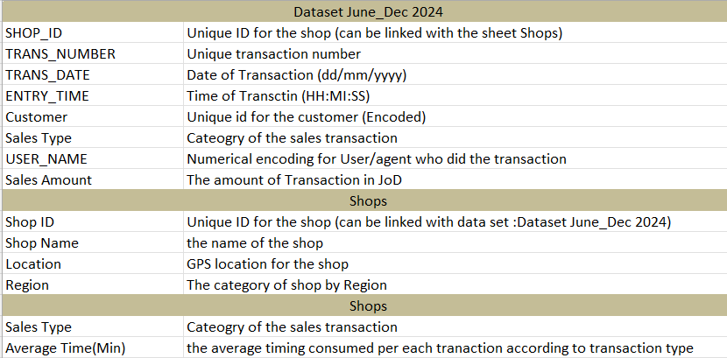

***Table Relationships***

The tables are interconnected as follows:

* The **Shops Table** is connected to the **Dataset June_Dec 2024** table (main table) via the SHOP_ID column in a **one-to-many relationship**.
* The **Transaction Average Time Table** is connected to the **Dataset June_Dec 2024** table (main table) via the Sales Type column in a **one-to-many relationship**.

These relationships, as shown in the image below, enable a comprehensive analysis of sales performance, shop distribution, and transaction efficiency.

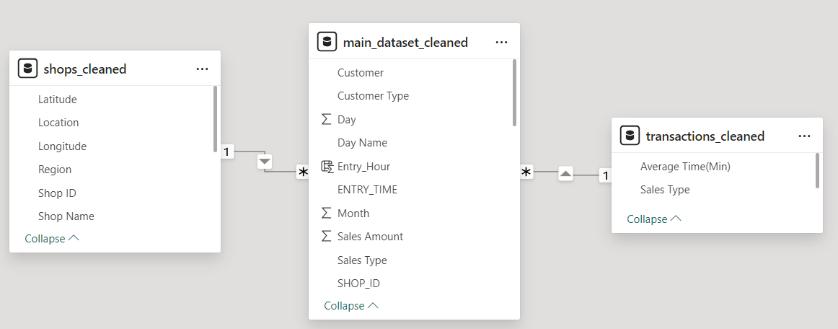

-------------------------------------------------------------------------------------------------------------------------------

When it comes to the value of the collected data and insights to **sales managers**, **agents**, and **company executives**, this dataset proves to be a powerful tool for making data-driven decisions. It offers (and provides) valuable insights that can enhance decision-making processes, improve sales performance, and support operational, tactical, and strategic planning.

For **sales managers**, the dataset provides key information that helps them assess the performance of different sales agents, shops, and sales types. The transactional data, for instance, allows managers to identify top-performing agents based on their sales contributions. Agents who excel can be rewarded with promotions or bonuses, while those underperforming can be identified for additional training and development.

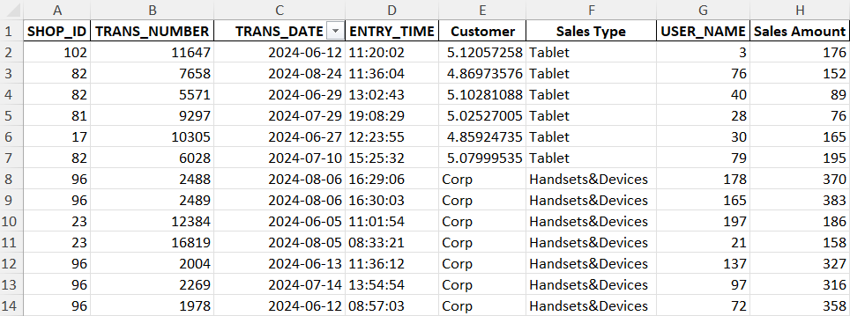

Additionally, the data enables **managers** to analyze shop performance, pinpointing which shops are thriving and which require upgrades or support to boost their efficiency.

From the **agents’ perspective**, this dataset enables them to better understand customer behavior and identify patterns in their purchasing habits. The customer-related data can be leveraged to develop personalized approaches to improve customer satisfaction and retention. By studying trends in sales types and transaction amounts, agents can focus on promoting products that align with customer preferences, ensuring a more targeted and effective sales strategy.

For **company executives**, the dataset provides a strategic overview that informs long-term decision-making. The geographical distribution of shops, captured in the Shops Table, offers insights into the regions that are well-covered and those with opportunities for expansion. This information can guide decisions on opening new shops in underserved areas to maximize market reach. Furthermore, the sales data enables executives to assess the performance of different sales types, identifying high-performing products for further investment and low-performing ones that may need discontinuation or re-evaluation.

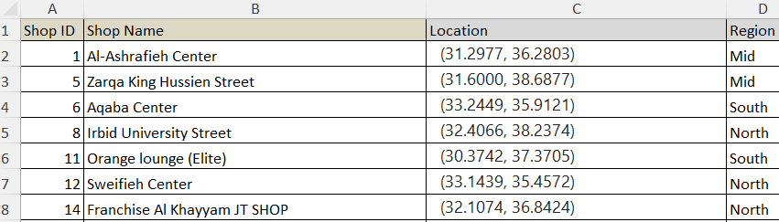

The dataset’s advantages extend beyond these immediate applications. Its moderate size ensures efficient processing, making it suitable for generating real-time dashboards and actionable insights. The information spans multiple aspects of sales, shops, agents, and customers, making it comprehensive and versatile. However, the dataset does have some **drawbacks (and limitations)**. It covers only three months – June, July, and August 2024 – limiting the ability to analyze long-term trends. Including data from additional months or years, such as 2022 and 2023, would provide a richer context and enable deeper analysis. Additionally, the absence of demographic information such as: customers’ age, gender, and income restricts the ability to conduct targeted marketing campaigns or perform detailed customer segmentation.

Another challenge lies in the presence of null values in the dataset, which need to be addressed to ensure the accuracy and reliability of the analysis. Despite these limitations, the dataset’s strengths far outweigh its weaknesses, offering a robust foundation for deriving meaningful insights. By leveraging the data effectively, sales managers, agents, and company executives can make informed decisions that drive sales growth, optimize operations, and achieve strategic goals. In conclusion, this dataset is a valuable resource for fostering a culture of data-driven decision-making within the organization.

# Q2. Propose clear questions and discussion points needed for elicitation sessions with: Sales Manager, Shop Manager, and Sales Performance Manager.

When it comes to the **questions and discussion points** that I proposed to the **sales manager**, **shop manager**, and **sales performance manager**, I carefully crafted a set of questions aimed at understanding their needs, expectations, and preferences for the dashboards. My goal was to ensure that the final product would not only meet their expectations; but also **fully satisfy their requirements** and be tailored to their specific roles and responsibilities. I asked numerous different questions to gather insights into their expectations for the dashboards, the type of information they wanted to see, how they wanted it presented, and any particular challenges they faced that I needed to address (and solve). Their answers were detailed and incredibly helpful, providing me with clear directions on how to proceed with the project and ensuring the dashboards fully align with their needs.

***Question 1***

One of the **first questions** I asked was directed to the **sales manager**, where I inquired if there were any **colorblind individuals** in their organization who would be using the dashboards and what specific **colorblindness challenges** they were facing. This question was particularly important because I wanted to ensure that the dashboards would be accessible to all users, including those with colorblindness. Addressing this consideration is not only about **user inclusivity** but also about leveraging the **human perceptual and cognitive system** effectively to ensure the dashboards are easily interpretable by everyone. The sales manager informed me that there were two individuals in the organization who had difficulty distinguishing the **purple color** due to colorblindness disease. Taking this into account, I decided that in all the dashboards and visuals I create, I would **avoid using purple entirely**. This decision ensures that the dashboards will be inclusive, respectful of their condition, and fully usable by all members of the organization.

***Question 2***

Another question that I asked the sales manager was about the meaning of **null values** (or, in simpler terms, **missing values**) in their dataset. I explained that I noticed some missing values in the dataset and, in order to technically create accurate visualizations and drawings, I would need to address these null values. While there are statistical methods to handle missing values, such as replacing them with the: (1) mean, (2) median, or (3) mode, I wanted to fully understand their significance in the context of the company’s data. I inquired whether null values in their dataset represented the most common value in that specific column, were caused by an error in the data-filling process, or had some other meaning. Knowing this would ensure that I handle the data in a way that preserves its integrity and value.

Understanding that this might be a technical question, I took care to phrase it in a non-technical way, asking the sales manager to consult with the people responsible for data entry at their company. After discussing with them, the sales manager informed me that missing values represent the most common (mode) value in the respective columns. He explained that sometimes, due to time constraints or laziness, the data entry personnel skip filling in these values even though they reflect the mode. This response was invaluable to me as it clarified how to address the missing values accurately (and correctly). I decided to use this insight to replace null values with the mode value in each column, ensuring that the dataset remains consistent and allowing me to derive the most accurate and meaningful insights during the visualization process.

***Question 3***

Another question that I asked to the sales manager, shop manager, and sales performance manager was about the **main problems they are facing** in their roles and what they are trying to solve through the use of data and dashboards. I inquired about the value or insights they expect to gain from the data and what specific information they expect the dashboards to provide (and give). Each of them shared their unique perspectives and challenges. The sales manager, for example, expressed that one of the biggest issues is the lack of a streamlined and organized approach for making decisions. He admitted that, at times, decisions are made **arbitrarily** and based on **assumptions** because it is difficult to scroll through and derive insights from extensive tables, sheets, and Excel files. He also mentioned struggling to compare sales types and products effectively using raw numbers in spreadsheets. He emphasized that he wishes for organized dashboards with insightful visualizations that would enable him to make data-driven decisions, save time and effort, and ultimately increase the company’s revenue and profitability.

Additionally, other managers and executives mentioned that the dashboards need to be organized into three specific levels: dashboards for **operational-level decisions** (for day-to-day tasks), dashboards for **tactical-level decisions** (focused on weekly and mid-term goals), and dashboards for **strategic-level decisions** (focused on long-term vision). The executives at the company also highlighted a pressing issue: they want to open a new shop but are unsure where to locate it. They explained that it is difficult (and hard) to identify underserved areas and make informed decisions about shop locations using Excel files alone. They expressed a desire for dashboards that would help them spot optimal locations for expansion, enabling them to open a shop in the most strategic and profitable area.

After gathering their input and taking detailed notes, I developed a comprehensive understanding of their expectations and challenges. I realized that my goal is to transform raw, hard-to-read, and hard-to-interpret data into insightful visualizations that cater to their needs across operational, tactical, and strategic levels. I also recognized that creating a geographical map visualization to display their current shop locations and highlight underserved regions would be incredibly valuable for strategic-level decision-making. These notes will guide me in designing dashboards that not only meet their expectations but also solve the core challenges faced by the company. My ultimate aim (and goal) is to create dashboards that provide actionable insights and help the company achieve its objectives efficiently and effectively.

***Question 4***

Another question that I posed to the sales manager and the company team stemmed from my initial exploration of the dataset. After scanning the data and gaining an understanding of its structure, I noticed a column labeled “”Customer””, which detailed each customer's transactions and the monetary value of their purchases. I asked them if it was possible to provide additional information about the customers, such as their age, gender, and other demographic details. I explained that having access to this data would enable me to provide more in-depth insights, including advanced customer segmentation, which could help them design more personalized and effective targeting campaigns. Furthermore, these demographic details could make their solutions more tailored and engaging for their customers.

The sales manager reacted positively to this suggestion and even laughed, admitting that this idea had never occurred to them before. He acknowledged the creativity behind the suggestion and said, “This is a brilliant idea. Unfortunately, we don’t currently have this information available, but you’ve given us a great idea for future improvement.” He added that they would inform the team to start collecting this kind of data, recognizing its potential value for enhancing sales strategies. Although the data was not immediately available, I felt satisfied knowing that my question had sparked a valuable new perspective for the company. It was rewarding to see that, while the idea could not be implemented immediately, it could drive future improvements in their business processes.

***Question 5***

After all the above questions, another crucial question came to my mind: “**Who are the main audiences for these dashboards, and what is suitable for each audience segment?**” I explained to the sales manager that I understand they have three types of audiences for the dashboards: day-to-day operational-level people, mid-level tactical managers who focus on weekly or monthly goals, and strategic-level executives who focus on the company’s long-term vision. However, my question was aimed at understanding the specific needs and expectations of each audience type. For instance, I asked which audience segments are interested in real-time insights, whether operational, tactical, or strategic people prioritize real-time data, and how granular or general the information displayed should be for each segment. I further inquired who would prefer seeing precise figures like 10,589 versus rounded trends such as 10k, who would benefit most from KPI-driven dashboards, and who might require simpler dashboards that highlight general patterns rather than intricate visualizations like boxplots.

The sales manager appreciated the depth of my questions and responded thoughtfully. He explained that **operational-level people** check dashboards frequently, often multiple times a day, and care deeply about exact numbers. For them, every detail counts, and they are well-equipped to interpret complex visualizations such as boxplots and handle KPI-rich dashboards. **Tactical-level people**, on the other hand, are less concerned with granular details and are content with seeing rounded figures like 10k rather than exact numbers. These individuals tend to check dashboards less frequently, usually once a day or once a week, and are more focused on trends over time rather than intricate details. Lastly, **strategic-level executives**, who have limited time to analyze dashboards, require visuals that are fast to interpret and easy to grasp. These individuals prioritize long-term trends and high-level overviews rather than specific metrics, as they may only review the dashboards once every two weeks or even once a month. They prefer streamlined, simple dashboards that convey the core message in just a few minutes, without requiring additional interpretation.

After taking detailed notes on their responses, I developed (and established) a clear understanding of the different audience segments and their expectations. This clarity allowed me to tailor the dashboards to the unique needs of each audience type, ensuring that every level – from operational staff to strategic executives – would find the dashboards useful, intuitive, and aligned with their decision-making processes. My goal became not just to design dashboards but to create informed dashboards that fully cater to the audience’s diverse needs, making their experience seamless and effective.

***Conclusion***

In-conclusion, the elicitation sessions I conducted with the sales manager, shop manager, and sales performance manager of the company were invaluable in understanding the client’s requirements and expectations. Across three one-hour sessions, I asked numerous questions, and the five discussed above were the most critical in shaping my approach to the project. These sessions provided me with a clear (and solid) understanding of what the client expects from the dashboards, the insights they wish to derive from the data, and the challenges they aim to address (and solve). They also helped me understand the distinct needs of each audience segment: operational-level staff expect real-time, detailed dashboards with KPI-rich visuals; tactical-level managers prioritize weekly trends and simplified metrics; and strategic-level executives require high-level overviews that are quick to interpret. The elicitation sessions laid a strong foundation for my next steps in the project by clarifying what problems need to be solved, what visuals are suitable for the audience, and how to present the information in an impactful way. For instance, the color-blindness question helped me design inclusive visuals, while the question about missing values guided me on how to address gaps in the data effectively. Overall, these sessions have provided me with the insights necessary to create tailored, informed, and impactful dashboards that will fully satisfy the client’s needs and support their decision-making processes at every given level.

# Q3. Explain, asses, and evaluate data set and provide recommendations to optimize provided datasets.

***Recommendation 1***

When it comes to explaining, assessing, and evaluating the dataset we have and providing recommendations to optimize it, several advantages (pros) and disadvantages (cons) are present in the dataset, and numerous recommendations come to mind for improvement. First and foremost, the dataset contains a significant amount of transactional data, with approximately 400,000 rows and 8 columns. This dataset is classified as medium-sized, which is advantageous because it is efficient for processing and analysis. Its manageable size ensures that processes will run smoothly without requiring excessive computational resources, as would be the case with a large-scale dataset. However, I believe that increasing the size of the dataset – by including more transactional records – would be a significant improvement. For example, if the dataset were expanded to 800,000 rows instead of 400,000 it would allow us to uncover deeper insights, gain more knowledge, generate richer visualizations, and identify additional patterns. Thus, the first recommendation for optimizing the dataset is to increase its size in the future by including more rows, which will lead to more comprehensive and meaningful analysis.

***Recommendation 2***

Another evaluation point for the given dataset, along with a related recommendation, concerns the quality and cleanliness of the data. The dataset contains numerous missing – null values across different columns and rows, which may arise (and emerge) from various reasons, such as employees rushing through data entry due to workload, errors during database storage processes, or other unforeseen issues. This lack of cleanliness in the data can lead to inaccurate or misleading insights and require extensive preprocessing efforts to address these gaps. Unclean data not only adds complexity to the analysis but also impacts the reliability and robustness of the results.

To optimize and improve the dataset, one recommendation is to implement measures that ensure the data is cleaner and of higher quality. For example, employees responsible for data entry should be encouraged to fill in the data more carefully and accurately. Training programs or tools that assist in error checking and validation during data entry could be introduced to minimize (and reduce) mistakes.

Additionally, establishing automated processes or data validation rules in the database system could help identify and address errors or missing values at the time of data collection. Cleaner and higher-quality data would result in more accurate, reliable, and actionable insights, ultimately supporting better decision-making and reducing the time and effort required (and needed) for preprocessing tasks.

***Recommendation 3***

Another evaluation point of the dataset and a recommendation for its improvement concerns the limited amount of information about customers. The dataset currently includes only transactional details, such as the products customers purchased and the monetary value of their transactions. However, it lacks any demographic information about the customers, such as their age, gender, or other relevant details. This limitation reduces our ability to perform customer segmentation or offer personalized experiences, as the dataset does not provide sufficient information to group customers into meaningful categories.

This lack of demographic data is a disadvantage because it restricts our personalization capabilities, making it difficult to design targeted advertising campaigns or tailored customer experiences. For instance, if demographic data were available, we could cluster customers into specific segments based on shared characteristics and target each segment with customized marketing strategies. Personalized approaches have the potential (and ability) to significantly enhance customer engagement and retention rates.

To address this limitation, a recommendation for future improvement is to begin collecting demographic information about customers during the data collection process. This additional data would not only enhance our ability to gain deeper insights into customer behavior but also enable more effective customer segmentation, ultimately leading to better decision-making and more impactful marketing efforts. Adding such data to the dataset would make it more comprehensive, unlocking new possibilities for analysis and personalization.

***Recommendation 4***

Another evaluation point of the dataset, along with a recommendation for improvement, concerns the limited timeframe of the data. Upon further examination, the dataset only includes transactional data for three months of the year 2024 – June, July, and August. While this amount of data is relatively sufficient for generating meaningful insights and recommendations for stakeholders across operational, tactical, and strategic levels, I believe that extending the timeframe would provide significant benefits. For instance, if the dataset included data from additional years, such as: 2021, 2022, and 2023, as well as data covering all 12 months of the year, it would enable us to identify deeper and more meaningful long-term trends.

Currently, the dataset’s limitation to three months restricts our ability to detect seasonal patterns or variations throughout the year. Similarly, having data from only one year prevents us from analyzing trends across multiple years, such as identifying growth patterns, year-over-year changes, or the impact of external factors over time. Thus, *therefore*, a strong recommendation for optimizing the dataset is to include transactional data for more months and multiple years. This expansion would allow for the identification of long-term trends and patterns, leading to more robust and actionable insights for decision-makers at all levels.

***Recommendation 5***

Many other recommendations and evaluation points regarding the dataset came to mind. Some notable and worth-mentioning limitations include the lack of certain details in the transactional data. For instance, the dataset provides the transaction date and time (e.g., 2024-06-12), but it does not indicate the day of the week (e.g., Sunday, Monday, etc.) or whether the transaction occurred on a weekend. While this limitation can be addressed using preprocessing techniques, including such information in the dataset would save time and effort and provide immediate insights into customer behavior based on weekdays versus weekends.

Another limitation is that the dataset identifies whether a customer is a normal client or a corporate, but it only mentions if they are a corporate without providing the name of the corporate or additional details about it. Having information about the specific corporates would allow us to delve deeper into corporate behavior and analyze trends or patterns within these organizations.

Additionally, the dataset includes the geographical location of shops but lacks details about the shops themselves, such as the number of agents or other operational characteristics. This missing information could be valuable for assessing shop performance and understanding resource allocation.

Lastly, while the metadata file provided with the dataset is clear and helpful, it could be further improved by offering more in-depth explanations about the data. For example, it could provide detailed descriptions of the columns, clarify any ambiguous terms, and explain how different tables in the dataset connect with each other. These enhancements would make the dataset easier to understand and work with, ultimately improving the overall analysis process.

***Conclusion***

In conclusion, while our dataset has several limitations and areas for improvement, I have outlined numerous – different recommendations to optimize and enhance its quality and utility. These include increasing the number of rows from 400,000 to a larger number of transactions, ensuring the data is cleaner with fewer missing values, incorporating more demographic information such as: customers’ age, gender, and other details, extending the timeframe to include data from additional years and months beyond June, July, and August of 2024, and addressing other specific gaps like providing the name of corporate clients or additional details about shops. These recommendations aim to make the dataset more comprehensive and more insightful.

That said, it is important to emphasize that these limitations do not mean the dataset is bad or lacking in value. On the contrary, the dataset contains a wealth of valuable insights and information that can significantly benefit stakeholders across operational, tactical, and strategic levels. For example, the dataset includes information about shop locations, which can be visualized on a geographical map to identify underserved areas suitable for new shop openings. It also provides transaction average time data, allowing us to categorize sales types into slow, medium, and fast transactions, highlighting areas for potential improvement. Additionally, the dataset contains data on sales agents, enabling the identification of top-performing agents for rewards and underperforming agents who might benefit from further training or support.

Overall, while the dataset has certain disadvantages (cons), it also offers numerous advantages (pros) that far outweigh its shortcomings. If I were to assess the dataset, I would confidently conclude that it is a valuable, insightful, and well-structured dataset that serves as a strong foundation for data-driven decision-making and actionable insights.

# Q4. Provide clear data abstraction and task abstraction summarization that you will rely on to design sales dashboard and describe how Data Visualization nested model had been applied to your dashboards and what can be optimized.

When it comes to data abstraction, task abstraction, and the application of the data visualization nested model, I began by thoroughly examining and testing the provided dataset. This process was informed by several elicitation sessions with key stakeholders, including the sales manager, shop manager, and sales performance manager. During these sessions, I asked targeted questions and engaged in in-depth discussions to fully understand their needs, expectations, and challenges. After gathering this valuable input, I started applying the steps of the ***Data Visualization Nested Model*** to guide (and direct) my approach to the project.

***Domain Situation***

In the **Domain Situation** phase of the nested model, I focused on understanding the client’s domain and the specific difficulty – challenges they face. The client operates in the telecom industry, and their primary goal is to increase sales by leveraging data to make informed, data-driven decisions. I learned that their data was previously stored in Excel files, which were described as boring, hard to read, and difficult to interpret. This created **pain points** for decision-making, as important insights were buried within tables that required significant effort to analyze.

One critical challenge was voiced by the strategic executives, who wanted to open a new shop but struggled to determine the optimal location by reviewing Excel files listing shop locations. They expressed a need for a **geographical map visualization** that could identify underserved areas, enabling them to strategically expand operations. Another pain point came from the sales manager, who sought to identify **top-performing agents** (those generating high sales) to reward and promote, while also pinpointing **low-performing agents** to provide retraining and support. Across all levels, there was a clear demand for dashboards that could transform their scattered, hard-to-interpret data into a **systematic, organized, and visually rich format**. These dashboards would allow (and enable) stakeholders to make accurate, robust, and actionable decisions based on data; rather than assumptions.

***Data Abstraction***

After completing the **Domain Situation** phase and gaining a comprehensive understanding of the telecom industry domain, the client’s pain points, and their expectations, I moved on to the **Data Abstraction** phase. This involved carefully analyzing the dataset to identify its structure, attributes, and potential for transformation. I thoroughly examined the dataset to determine the data types of each column, their cardinalities, and their roles in connecting different tables. Additionally, I made informed decisions on how to handle missing values, create derived columns, and prepare the data for visualization.



For instance, I identified key columns in the dataset:

* Shop_ID 🡪 A numerical column containing integer values that serve as unique identifiers for different shops. This column connects the **Transactions Table** with the **Shops Table**, enabling us to join the two tables and analyze shop-related data effectively.
* Trans_Date 🡪 A date column storing transaction dates from the months of June, July, and August 2024. This column is essential for identifying trends over time.
* Location 🡪 A geographical column that provides the latitude and longitude of shop locations, enabling geographical mapping to visualize shop distribution and identify underserved areas.

I applied similar analysis to all columns, ensuring (and making sure of) a full understanding of the dataset’s structure and potential.

I also performed data transformations and derived new columns to enhance our analysis. For example:

* From the **Trans_Date** column, I derived additional columns such as: **Month**, **Day**, **Year**, and **Day Name** to gain a deeper understanding of transaction patterns across different time periods. These derived columns enable us to analyze how transactions vary by day of the week or by month, providing valuable insights.

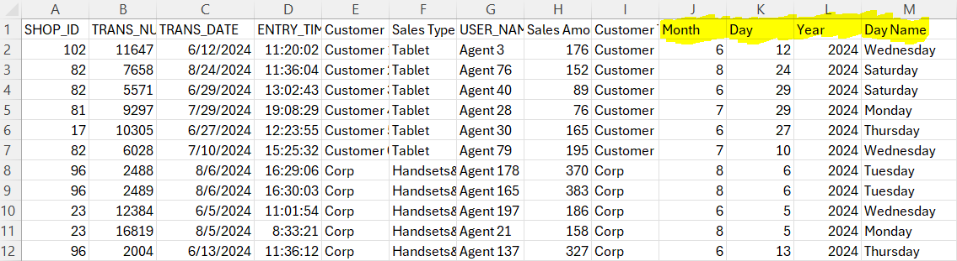

* I created a new column called **Customer_Type** from the existing **Customer** column. The original data contained unique customer identifiers along with the label **Corp** for corporate customers. By deriving the **Customer_Type** column, I categorized customers as either **Normal Client** or **Corporate**. This allows us to analyze customer type frequencies and behaviors more effectively (and efficiently).

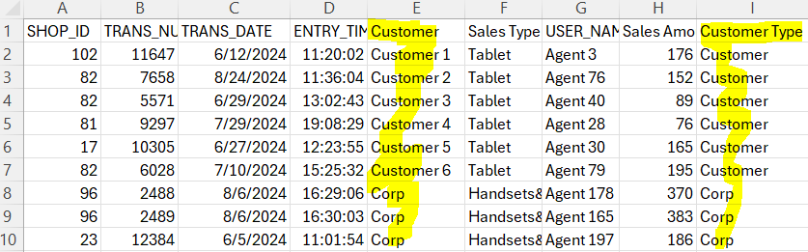

In the **Data Abstraction** phase, I focused on answering the **WHAT?** questions:

* What data do we have?
* What we are trying to achieve?
* How can the data support our goals.

I ensured the data was well-prepared and organized to address (and tackle) the client’s needs through dashboards and visuals. For example:

* The **Shops Table** enables us to visualize shop distribution geographically, helping strategic executives identify underserved areas for potential shop expansion.
* The **Transaction Average Time Table** helps analyze average transaction times for different sales types, allowing us to identify slow-performing sales types that require (and need) improvement.
* The main **Transactions Table** provides rich insights, such as: identifying top-performing agents, spotting patterns in sales trends, understanding how sales vary across time, and much more.

Through this meticulous approach, I ensured (and made sure that) the data was transformed into actionable insights, ready to address the client’s pain points and support the development of meaningful dashboards.

***Task Abstraction***

After completing the Domain Situation phase, where we gained a deep understanding of the telecom domain and its challenges, and the Data Abstraction phase, where we identified the dataset’s structure and answered the WHAT questions, we moved on to the Task Abstraction phase. In this phase, we focused on addressing the WHY questions – why we are undertaking specific tasks, why we are designing certain dashboards, and how these dashboards can provide value to the stakeholders.

For instance, in the WHAT phase, we decided to create a dashboard for strategic-level stakeholders that displays the geographical distribution of shop locations. In the WHY phase, we delved deeper to answer why this dashboard is essential. The answer, after careful analysis and consideration, is that this dashboard will enable strategic executives to identify areas with a strong shop presence and uncover underserved regions that offer opportunities for expansion. By visualizing shop distribution, decision-makers can strategically plan new shop openings in high-potential areas, ultimately boosting revenue and market presence.

Similarly, for tactical-level stakeholders, we determined in the WHAT phase that a dashboard should include KPIs and insights about shop performance and sales agents. In the WHY phase, we justified this decision by explaining how these insights can benefit them. For example, performance KPIs can help them identify top-performing shops that may need additional resources to sustain their success or low-performing shops that may require intervention, such as: increasing staff or improving management practices. Moreover, identifying top-performing sales agents can facilitate rewarding and promoting them, while identifying underperforming agents can guide retraining efforts to improve their contribution to the company’s goals.

Another example is the decision to show operational-level stakeholders insights into transaction average times by sales type. By answering the WHY question, we concluded that this information is crucial for identifying sales types that are slower and require process optimizations to improve efficiency. This not only reduces delays; but also enhances customer satisfaction and operational performance.

The Task Abstraction phase of the Data Visualization Nested Model was crucial (and vital) in ensuring that every design decision was justified and aligned with the stakeholders’ goals. By systematically addressing the WHY questions, we ensured that the dashboards provide actionable insights, are aligned with the stakeholders’ needs, and help solve the client’s core (and main) challenges effectively.

***Visual Encoding***

Finally, after completing the Domain Situation phase (understanding the telecom domain and its challenges), the Data Abstraction phase (answering the WHAT questions), and the Task Abstraction phase (answering the WHY questions), it was time to move into the Visual Encoding phase. In this phase, I focused on selecting appropriate marks, channels, colors, visuals, and KPIs to design effective dashboards and complete the Data Visualization Nested Model by addressing the HOW questions – how to create the dashboards to best communicate insights. I carefully chose visuals that were most suitable for the specific information being presented. For instance, I avoided using the purple color in all dashboards since the client mentioned (and stated) that some individuals within their organization have purple color blindness. I ensured that the design leveraged the human perceptual and cognitive system effectively, prioritizing clarity and intuitiveness. Each dashboard was tailored to tell a specific story, presenting the right amount of information – neither too cluttered nor overly simplistic – to maintain full focus and ensure usability.

***Conclusion***

In-conclusion, I followed and applied the Data Visualization Nested Model step-by-step to ensure a systematic approach to designing effective dashboards. Starting with the Domain Situation phase, I focused on understanding the client’s telecom domain, their challenges, and their expectations. The client faced difficulties deriving insights from raw Excel files and needed data-driven dashboards tailored to operational, tactical, and strategic decision-makers. Next, in the **Data Abstraction phase**, I carefully analyzed the dataset, identified its structure, attributes, and potential transformations, and addressed the WHAT questions to understand how the data could support our goals. In the **Task Abstraction phase**, I delved deeper into answering the WHY questions, justifying each task and dashboard design decision by considering how the dashboards could provide actionable insights and solve the client’s core (and main) challenges. Finally, in the **Visual Encoding phase**, I addressed the HOW questions by designing dashboards with appropriate marks, channels, colors, visuals, and KPIs, ensuring that they were intuitive, inclusive, and fully aligned with stakeholder needs (and requirements).

The data abstraction and task abstraction summarization that I will rely on when designing the dashboards are rooted in understanding the client’s need to visualize shop distributions, monitor sales agent performance, and analyze transaction efficiency. These abstractions ensure that the dashboards effectively support decision-making at all organizational levels.

Regarding the optimization of the Data Visualization Nested Model, there are areas for potential improvement. While I conducted three elicitation sessions, scheduling additional sessions could have provided even deeper insights into stakeholder needs. Additionally, as I was not an expert in the telecom industry, dedicating time to familiarize myself further with the industry by reading articles and case studies could have enhanced my understanding and alignment with the client’s context. Lastly, the entire process was completed within two weeks, which, while efficient, might have benefited from additional time to refine and strengthen the model’s application. These considerations highlight (and show) opportunities for further improvement and learning, ensuring an even more powerful and impactful application of the Data Visualization Nested Model in future projects.

# Q5. Design sales dashboard using Power BI to build a clear and informative dashboard. Your dashboard should clearly show summary statistics about the major variables and help the audience quickly understand the sales landscape.

Dashboard 1

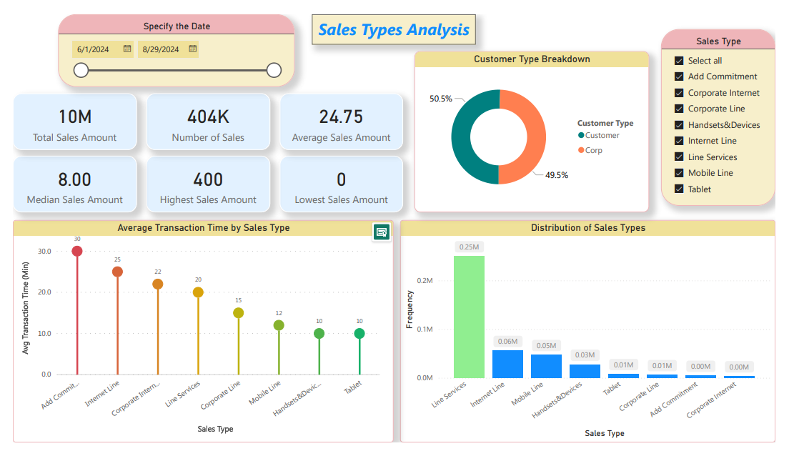

Dashboard 1 – Operational – Sales Types Analysis:

* Focus 🡪 Analyzing sales types performance.
* Target Audience 🡪 Operational-level team.
* Includes KPIs, pie charts, lollipop charts, and column charts.

Dashboard 2

Dashboard 2 – Tactical – Shops Analysis:

* Focus 🡪 Insights into shop performance.
* Target Audience 🡪 Tactical-level personnel.
* Includes slicers for region/shop and visualizations like treemaps, KPIs, and line charts.

Dashboard 3

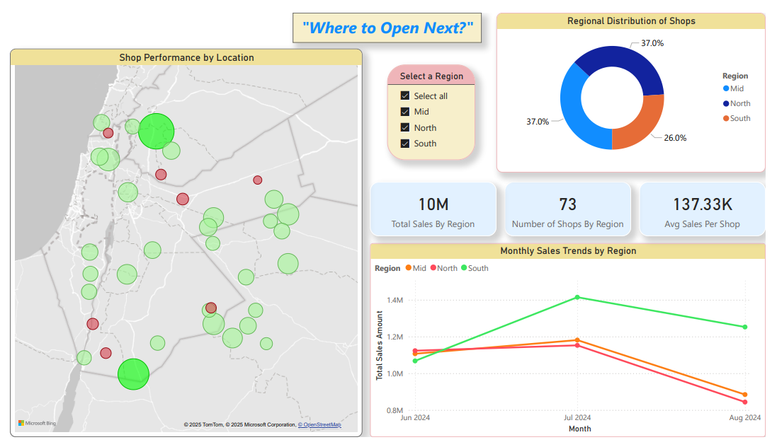

Dashboard 3 – Strategic – Location Optimization (“Where to Open Next?”):

* Focus 🡪 Optimizing shop locations for future openings.
* Target Audience 🡪 Strategic-level decision-makers.
* Features a map, regional distribution pie chart, and sales trends by region.

Dashboard 4

Dashboard 4 – Operational – Daily Transaction Insights:

* Focus 🡪 Understanding daily transaction patterns.
* Target Audience 🡪 Operational-level team.
* Includes line charts for sales trends, bar charts for weekday/hourly distribution, and customer type breakdown.

Dashboard 5

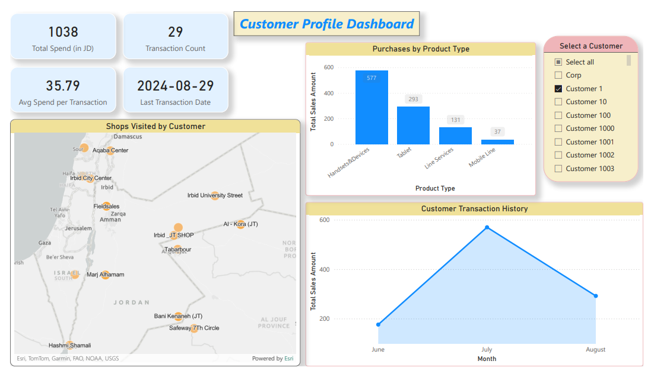

Dashboard 5 – Operational – Customers Analysis (Customer Profile Dashboard):

* Focus 🡪 Analyzing individual customer behaviors and transaction history.
* Target Audience 🡪 Operational-level team.
* Features maps, product type sales, and transaction history.

Dashboard 6

Dashboard 6 – Tactical – Agents Analysis (Agent Performance Analysis):

* Focus 🡪 Evaluating agent performance.
* Target Audience 🡪 Tactical-level team.
* Includes KPIs, a gauge chart for sales vs. targets, box plots, and detailed transaction tables.

Dashboard 7

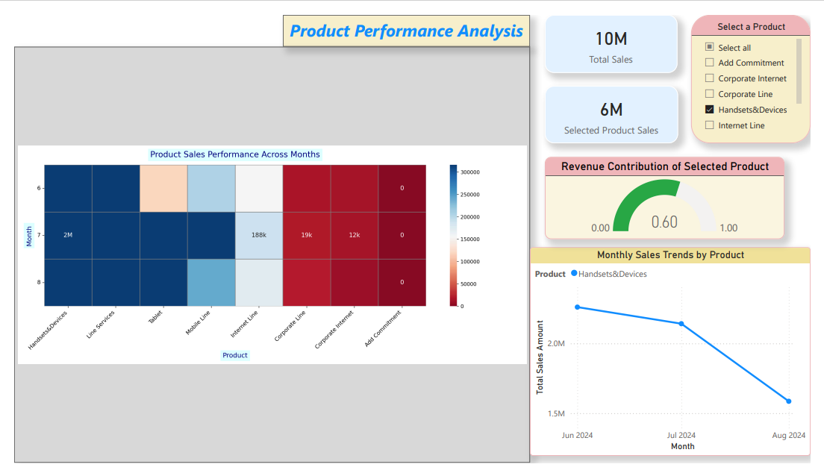

Dashboard 7 – Strategic – Product Performance Analysis:

* Focus 🡪 Tracking product sales performance over time.
* Target Audience 🡪 Strategic-level team.
* Includes heatmaps, KPIs, line charts, and revenue contribution visualizations.

Dashboard 8

Dashboard 8 – Tactical – Average Transaction Time Analysis:

* Focus 🡪 Analyzing transaction time efficiency.
* Target Audience 🡪 Tactical-level team.
* Includes density plots, box plots, and lollipop charts for transaction time by sales type.

Dashboard 9

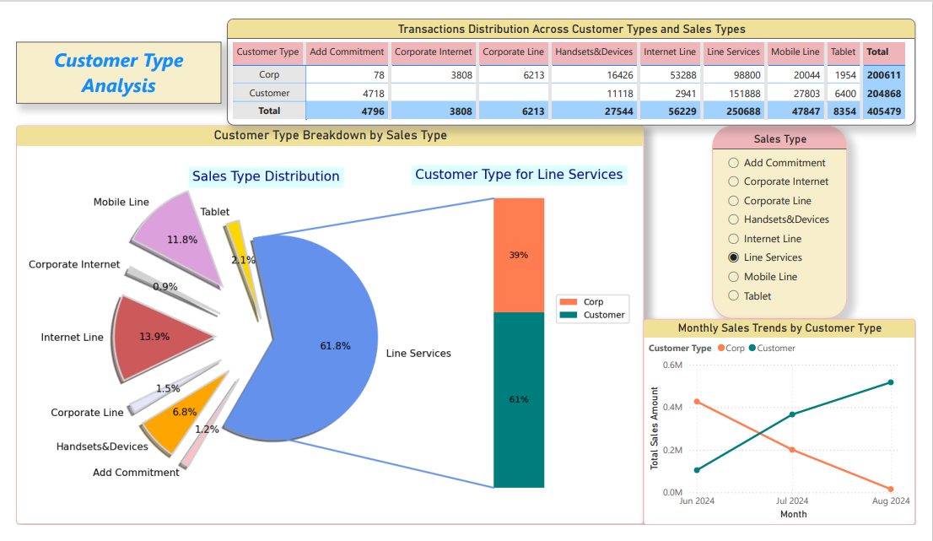

Dashboard 9 – Tactical – Customer Type Analysis:

* Focus 🡪 Evaluating customer types and their sales contributions.
* Target Audience 🡪 Tactical-level team.
* Includes pie charts, stacked bar charts, and customer type breakdown by sales type.

Dashboard 10

Dashboard 10 – Tactical – Sales Agents and Shops Analysis:

* Focus 🡪 Relationship analysis between sales agents and shops.
* Target Audience 🡪 Tactical-level team.
* Includes KPIs, scatter plots, and bar charts.

-------------------------------------------------------------------------------------------------------------------------------

# Q6. Explain how the dashboards are utilizing the human perceptual and cognitive system.

***Dashboard 1***

When it comes to explaining how the dashboards utilize the human perceptual and cognitive systems, I fully ensured that all 10 dashboards effectively engage both systems while maintaining clarity and usability. The dashboards are designed to leverage **System 1** (fast, intuitive thinking) for immediate visual insights and **System 2** (slow, analytical thinking) for deeper analysis and decision-making. For example, in **Dashboard 1 – Operational – Sales Types Analysis**, as shown in the image below, I incorporated key features to support both perceptual and cognitive systems – at the same time (simultaneously).

For **System 1**, the **column chart** clearly identifies the most frequent sales type, with “”Line Services”” highlighted in green to signal a positive trend. The use of green as a positive color leverages the **human perceptual system**, allowing the user to intuitively interpret this as favorable without requiring conscious thought. Similarly, the **lollipop chart** depicting average transaction time employs a gradient of colors from **red (slow)** to **green (fast)**, helping users instantly distinguish between slow, medium, and fast transaction times. These color-coded cues provide immediate insights through pre-attentive processing, enabling the user to grasp important patterns effortlessly – without any effort.

For **System 2**, the dashboard included **six KPIs** (e.g., total sales amount, number of sales, average sales amount), which require users to engage in analytical thinking and interpret detailed numerical insights. Additionally, the **pie chart** showing the breakdown of customer types (50.5% customers, 49.5% corporate) encourages users to analyze proportions and distributions, supporting informed decision-making. The **slicers** for selecting sales types and specific dates further enable users to explore and filter data interactively, catering to their need in-depth, analytical exploration.

Dashboard 1

***Dashboard 2***

When it comes to Dashboard 2 – Tactical – Shops Analysis, I ensured that it engages both System 1 and System 2 effectively to deliver actionable insights. For **System 1**, the line chart visualizing **monthly sales trends by region** uses a green line for the south region, intuitively indicating that it has the highest total sales amount, signifying a positive trend. In contrast, the north region is represented in red, symbolizing its low and problematic sales performance, while the mid region is shown in orange, indicating a moderate yet concerning performance. This color-coded approach leverages (and uses) the human perceptual system by allowing the user to quickly interpret trends without conscious effort, using pre-attentive processing to highlight (and show) critical information. Similarly, the **treemaps** displaying the **top 5** and **bottom 5 shops by total sales** utilize size differences to immediately show performance levels – for instance, the larger block size of “Enterprise Corporate” clearly signals its superior sales performance compared to smaller blocks like “Flagship Shop”. These visual cues allow users to identify high- and low-performing shops at a glance.

For **System 2**, the dashboard includes **three KPIs** (total sales amount, number of transactions, and average sales per transaction), which require users to engage in deeper analytical thinking to interpret and compare numerical insights. Additionally, the **two slicers** enable users to filter and explore specific regions or shops interactively, fostering more detailed exploration and comparison. The treemap visualizations, while visually distinct by color for each shop, use size as the primary indicator, inviting users to cognitively assess and rank shop performance based on total sales. This combination of intuitive visuals and analytical tools ensures that the dashboard effectively supports decision-making for tactical-level stakeholders.

***Dashboard 3* – Strategic – Location Optimization (“Where to Open Next?”)**

When it comes to Dashboard 3, I ensured it effectively engages both the human perceptual and cognitive systems, delivering insights tailored to strategic-level decision-making. For system 1, the map visualization plays a central role by using intuitive visual cues. The size of the dots on the map represents shop performance – larger dots indicate higher sales, while smaller dots indicate lower sales. This leverages (and uses) the human perceptual system by enabling stakeholders to quickly identify high- and low-performing shops at a glance. Additionally, the color coding further enhances this functionality: green dots signify well-performing shops, while red dots signal underperforming shops, drawing immediate attention to areas requiring improvement or opportunities for expansion. These pre-attentive visual elements allow users to process critical insights instantly and without any effort.

For System 2, the dashboard incorporates analytical tools and visualizations that foster deeper thinking and decision-making. The pie chart on regional shop distribution enables stakeholders to analyze how shops are distributed across regions, with precise percentages providing a clear view of market presence in each area. The KPIs (e.g., total sales by region, number of shops by region, average sales per shop) prompt users to engage in a detailed evaluation of sales performance metrics, allowing them to compare regions and derive actionable insights. Furthermore, the line chart showing monthly sales trends by region provides a temporal dimension to the analysis, enabling stakeholders to track sales performance over time and identify consistent patterns or anomalies.



The combination of intuitive visual cues for fast insights (System 1) and detailed analytical tools for deeper exploration (System 2) ensures that the dashboard is both user-friendly and insightful. By carefully balancing the two systems, the dashboard helps strategic decision-makers prioritize actions, identify underserved regions, and make data-driven decisions on where to open the next shop. This design ensures clarity and usability, aligning with the stakeholders’ goals and optimizing the decision-making process.

***Dashboard 7* – Product Performance Analysis**

When it comes to dashboard 7, this dashboard effectively integrates both the human perceptual and cognitive systems, ensuring stakeholders can gain actionable insights into product performance across months. For **System 1**, the heatmap visualization employs a gradient of colors ranging from blue to red. Blue represents high-performing products across specific months, red indicates low-performing products, and white represents average-performing products. This intuitive color scheme taps into the human perceptual system, enabling users (and making them capable) to quickly and effortlessly identify patterns in product performance at a glance. Furthermore, the inclusion of numerical values within the heatmap allows users to validate and analyze these visual insights, bridging the gap between fast, intuitive thinking and deeper analytical reasoning.

The gauge chart enhances this design by visualizing revenue contribution for a selected product, using a dynamic color scheme. Green represents good revenue contributions, orange indicates medium performance, and red highlights low contributions. This interactive visualization is highly effective for **System 1**, as it uses universally recognized colors to provide immediate feedback on the revenue contribution of a specific product. The simplicity and clarity of the gauge chart allow stakeholders to intuitively gauge product performance without additional cognitive load. At the same time, the precise numerical value displayed on the gauge supports **System 2**, fostering deeper analysis and comparison with other products.

For **System 2**, the dashboard also incorporates KPIs, such as total sales and selected product sales, enabling users to engage in detailed evaluation and comparison of performance metrics. The line chart depicting monthly sales trends for selected products adds a temporal dimension, helping users analyze performance fluctuations over time. This combination of intuitive visual cues and detailed analytical tools ensures that stakeholders can make well-informed, data-driven decisions about product strategies and identify opportunities for improvement or growth.



***Dashboard 9* – Tactical – Customer Type Analysis**

When it comes to Dashboard 9, it effectively utilizes both the human perceptual and cognitive systems to provide actionable insights for tactical-level decision-making. For System 1, the pie chart visualizes the sales type distribution, where larger pie slices represent a greater share, and smaller slices indicate lower distributions. This visual cue helps users quickly understand the relative contributions of different sales types without the need for conscious effort or detailed analysis. The dashboard also maintains consistency in its use of colors: orange consistently represents “Corp” and navy represents “Customer” across both the stacked bar chart and the line chart. This uniform color scheme enables users to intuitively associate orange with Corp and navy with Customer, improving their ability to link and process information quickly across different visualizations.

For System 2, the dashboard includes a detailed table that represents numerical data on transactions across customer types and sales types. This table supports deeper analysis and comparison, allowing stakeholders to evaluate specific values and distributions in greater detail. Additionally, the stacked bar chart and line chart provide temporal and categorical insights, helping users analyze trends and compare customer types over time. By combining intuitive visual elements for quick insights with detailed analytical tools for deeper exploration, the dashboard ensures clarity, usability, and alignment with the stakeholders’ decision-making needs (and requirements).



***Conclusion***

In conclusion, the dashboards effectively utilize the human perceptual and cognitive systems to deliver actionable insights while maintaining full clarity and usability. By leveraging System 1 (fast, intuitive thinking) and System 2 (slow, analytical thinking) in a balanced and complementary manner, the dashboards cater to the needs of various stakeholders, from operational to tactical and strategic decision-makers. System 1 is utilized through intuitive visual cues like: color coding, size, and pre-attentive processing to provide instant (and fast) insights. For example, in Dashboard 1, green is used to highlight positive trends in sales types, while a gradient of red to green in the lollipop chart communicates transaction time efficiency. Similarly, in Dashboard 3, the map visualization uses green dots for high-performing shops and red for underperforming ones, with dot size representing total sales, making it easy for users to grasp performance patterns at a glance.

System 2 is supported through detailed analytical tools and visualizations that encourage deeper thinking and exploration. KPIs, as seen in Dashboard 7, provide clear numerical insights into total and selected product sales, while tables in Dashboard 9 enable stakeholders to compare and analyze transaction data across customer and sales types. Temporal trends, such as the monthly sales trends in Dashboards 2 and 3, add a time dimension to the analysis, allowing users to identify fluctuations and patterns over time.

Additionally, **marks and channels** are used effectively throughout the dashboards to ensure data is represented clearly and meaningfully. For instance, in Dashboard 1, bar length in the column chart and lollipop chart serve as effective marks to communicate sales frequency and transaction time, respectively. In Dashboard 7, the heatmap employs color intensity as a mark to represent performance levels across months. Channels, such as color, size, and spatial position, are used strategically across dashboards. In Dashboard 2, treemap block sizes indicate shop performance, while consistent color usage in Dashboard 9 (orange for “Corp” and navy for “Customer”) ensures users can easily associate elements across multiple visualizations.

Overall, these dashboards demonstrate (and show) a careful and thoughtful design that integrates both intuitive and analytical elements, ensuring a seamless experience for stakeholders; while aligning with their decision-making needs. This balanced approach maximizes the utility of the dashboards, making them both user-friendly and insightful (at the same time – simultaneously).

# Q7. Explain the value of having the right selection of the visual design in your dashboard.

***Dashboard 1***

When it comes to explaining the value of having the right selection of visual design in the 10 dashboards that we created, I can confidently say that the value lies in ensuring the dashboards are **clear, engaging, and insightful.** The right visual design – choosing the correct visuals (e.g., scatter plots, box plots, heatmaps), appropriate marks and channels, and using colors effectively – helps stakeholders quickly interpret the data, generate actionable insights, and make decisions efficiently (and effectively). In addition, the right selection of visuals enhances the usability and clarity of the dashboard by aligning with its purpose, audience, and the story it conveys. Furthermore, the balance between presenting too much and too little information is critical. Overloading a dashboard with excessive details can confuse users and reduce its effectiveness, while providing too little information may limit its usefulness. A well-designed dashboard achieves a balance, presenting just the right amount of information for its target audience and purpose.

In Dashboard 1 – Operational – Sales Types Analysis, I ensured that the visual design was thoughtfully selected and executed. For example, I used clear and accessible colors, avoiding purple, as some individuals in the target audience have purple colorblindness. This decision ensures inclusivity and enhances usability. Each dashboard focuses on one specific story or purpose – in this case, analyzing the performance of sales types – and is tailored for the operational-level audience. The title, ‘Sales Types Analysis’, further reinforces this focus.



The visuals were chosen carefully to align with the data and the goal. For instance, a column chart was selected to display the frequency distribution of sales types, **as column charts are highly effective for this purpose.** To emphasize the standout sales type, ‘Line Services’, I used a green color, contrasting with the blue colors for other sales types. This choice intuitively signals a positive trend and draws the user’s attention to the key insight. Additionally, numerical values were displayed within the column chart to enable deeper analysis if needed, addressing the potential confusion caused by merely visualizing bar heights. The lollipop chart was similarly enhanced with gradient coloring from red to green, visually representing the efficiency of transaction times. These choices support both quick interpretation and detailed analysis, catering to System 1 and System 2 processing.

For the pie chart, I selected a donut-style visualization to represent the breakdown of customer types (Corp vs. Customer). The donut chart was particularly suitable (and appropriate) here because it clearly conveys proportions while providing ample space to display the percentage values within the chart for further clarification. Additionally, this chart supports the user in understanding the relative contribution of each customer type to the total sales landscape.

Finally, I ensured (and made sure) that inappropriate visuals, such as treemaps or heatmaps, were avoided in places where they wouldn’t suit the data. For example, treemaps might not effectively communicate the distribution of sales types, as column charts are more intuitive for showing categorical frequency. By maintaining this deliberate and thoughtful approach to visual design, I ensured that Dashboard 1 effectively supports its intended purpose while remaining 🡪 (1) fully clear, (2) engaging, and (3) usable.

***Dashboard 2*** **– Tactical – Insights into Shop Performance**

Another example of the value of selecting the right visual design can be seen in **Dashboard 2 – Tactical – Insights into Shop Performance**. This dashboard effectively employs appropriate visuals and design elements to help users understand shop performance and trends efficiently. For example, the **line chart** visualizing **monthly sales trends by region** (June, July, and August) was chosen as the most suitable option for showing trends over time. Line charts are inherently intuitive for temporal data and make it easy for users to identify patterns, compare trends across regions, and derive actionable insights. Choosing any other visualization, such as: a pie chart or heatmap, would not have been as effective for this purpose, as these visuals are less suited for time-series data. The use of the **line mark** in this chart adds clarity and simplicity to the visual design.

The **color channel** further enhances the line chart’s value by conveying crucial insights: the **green line for the South region** indicates superior performance, while the red line for the North region highlights the lowest performance. The **orange line for the Mid region** suggests a performance that is slightly better than the North but significantly worse than the South. This intentional use of color helps users quickly interpret regional disparities and trends, reinforcing the importance of thoughtful design in delivering clear insights.

Additionally, the inclusion of **treemaps** to display the **Top 5 and Bottom 5 shops by total sales** demonstrates the right selection of visual design. Treemaps are particularly effective for showcasing hierarchical or proportional relationships, such as comparing shop sales performance. The size of the blocks in the treemaps visually represents the magnitude of sales, while the colors help differentiate between the top-performing and bottom-performing shops. This design ensures that users can easily grasp shop performance rankings at a glance.

By making deliberate and thoughtful choices in visual design, Dashboard 2 enables tactical-level stakeholders to identify high-performing shops, recognize underperforming regions, and make data-driven decisions to optimize shop performance. This approach highlights (and shows) the critical value of selecting the right visual design in ensuring that dashboards are clear, engaging, and actionable.

***Dashboard 3* – Strategic – Location Optimization (“Where to Open Next?”)**

Another example of the value of having the right selection of visual design in our dashboards is the geographical map visualization in Dashboard 3 – Strategic – Location Optimization (“Where to Open Next?”). This map visual is particularly suitable for the latitude and longitude data of shops that we have, as it effectively represents spatial data in a way that no other visualization can. Unlike pie charts, column charts, or other visuals, the geographical map excels at displaying shop locations and performance across a geographical area, making it the most appropriate choice for this data.

The use of dots to represent shops enhances the value of this visual. The sizes of the dots provide an intuitive understanding of shop performance, with larger dots indicating higher-performing shops and smaller dots signaling lower-performing ones. The color channel further amplifies the insights by assigning green to high-performing shops and red to underperforming ones, instantly drawing attention to areas requiring improvement or expansion opportunities. This deliberate and thoughtful selection of visual design ensures that stakeholders can quickly grasp spatial patterns and make informed decisions.

This geographical map visual serves as a strong example of how the right selection of visual design enhances the usability and impact of the dashboard, demonstrating the importance of aligning visuals with the nature of the data and the insights they aim to deliver.



***Conclusion***

In-conclusion, the right selection of visual design is crucial (and vital) to creating clear, engaging, and insightful dashboards that effectively meet the needs of their intended audience. By thoughtfully choosing the appropriate visualizations, such as column charts, line charts, and geographical maps, and using marks, channels, and colors strategically, our dashboards achieve their goals of presenting data in a way that is both intuitive and analytically useful. This balance ensures that stakeholders can quickly interpret trends, derive actionable insights, and make informed decisions.

As demonstrated in the examples of Dashboard 1, Dashboard 2, and Dashboard 3, the careful selection of visual designs plays a pivotal role in enhancing usability and clarity. In **Dashboard 1**, we used accessible colors, suitable visuals like column charts and donut charts, and numerical values to ensure operational-level stakeholders can understand sales type performance effortlessly. **Dashboard 2** emphasized shop performance through line charts, color-coded trends, and treemaps to highlight regional disparities and shop rankings, making it a valuable tool for tactical-level decision-making. Similarly, **Dashboard 3** utilized a geographical map to represent shop locations and performance, with dot sizes and colors intuitively conveying critical insights for strategic-level planning.

Furthermore, our dashboards follow the principle of presenting the right amount of information – neither overwhelming the user with excessive details nor omitting key insights. Each dashboard tells a specific story, tailored to its target audience, whether operational, tactical, or strategic. This deliberate approach ensures that all dashboards **remain clear, actionable, and aligned with their purpose.**

The value of selecting the right visual design extends beyond aesthetics. It fosters **better user engagement, enhances decision-making efficiency, and ensures that the insights presented are actionable and impactful.** This approach brings significant benefits, such as enabling stakeholders to explore data meaningfully, identify patterns and trends, and prioritize actions with confidence. By adhering to these principles across all dashboards, we ensure that they serve as powerful tools for driving informed, data-driven decisions across the organization.

# Q8. Clarify the methods used in selecting and designing your visualization design (chart type, Marks and Channels, Visual encoding techniques).

***Dashboard 1***

When it comes to clarifying the methods used in selecting and designing my visualization design, I ensured that each dashboard utilized the most appropriate chart types, marks, channels, and visual encoding techniques to effectively represent the data and provide actionable insights to the intended audience. The goal was to enhance clarity, usability, and interpretability; while ensuring the dashboards align with the decision-making needs of stakeholders. In **Dashboard 1 – Operational – Sales Types Analysis**, I carefully selected visualizations like: the column chart, lollipop chart, and donut chart, as each was most suitable for the data type and the insights it aimed to deliver.



For the **column chart**, I used it to display the distribution of sales types because it is highly effective for comparing categorical data, such as sales types, in terms of frequency or magnitude. This chart type allows stakeholders to easily identify which sales type had the highest frequency, making it ideal for operational-level decisions. Using other chart types, like heatmaps or scatter plots, would not have been as effective for this purpose, as they are less suited for showing categorical distribution. Similarly, the **lollipop chart** was selected to represent the average transaction time for each sales type because it provides a clear and engaging way to compare numerical data across categories. The circular marks at the end of the bars make it easier for users to focus on specific values, enhancing clarity and engagement. While a standard bar chart could have been used, the lollipop chart was chosen to make the visualization more visually appealing and easier to interpret. For the **donut chart**, it was the best option to represent the customer type breakdown (Corp vs. Customer). This chart type effectively conveys proportions in a visually engaging manner, emphasizing the relative relationship between the two customer types. Unlike bar charts or column charts, the donut chart better highlights proportions while leaving room for additional details, making it the most appropriate choice for this data.

**When it comes to marks,** I used bars in the column chart to represent the frequency of each sales type. Bars are ideal for this purpose because their length is directly proportional to the frequency, making comparisons straightforward and intuitive. In the lollipop chart, I combined lines (for the stems) and circles (at the ends) as marks. This combination provides both structure and focus, with the circles drawing attention to specific transaction times while the lines maintain the categorical structure. In the donut chart, I used slices as the primary marks, where the size of each slice corresponds to the proportion of each customer type. These marks ensure the data is communicated clearly and meaningfully to the user.

**For channels,** I applied different strategies across the visualizations. In the column chart, the primary channel was position, where the height of the bars on the y-axis represented the frequency of each sales type. I also used color strategically by highlighting "Line Services" in green to emphasize its dominance, while other categories were shown in blue for differentiation. In the lollipop chart, I used the length of the bars to represent the average transaction time, with a color gradient from red (slowest) to green (fastest) to visually encode transaction efficiency. This gradient helps users quickly associate red with delays and green with efficiency. In the donut chart, colors were used to differentiate between the "”Customer”" and "”Corp”" segments, but they did not encode specific data meanings beyond making the two segments visually distinct. The arc length of each slice in the donut chart was the primary channel, as it represented the proportional share of each customer type.

Finally, I applied visual encoding techniques thoughtfully to enhance interpretability. In the column chart, the height of the bars was used to encode the frequency, while the green color for "Line Services" served as a positive visual cue to draw attention to the top-performing category. In the lollipop chart, encoding was achieved through the length of the bars for transaction time and the color gradient to visually encode performance levels. In the donut chart, the arc length of each slice encoded the proportion, with colors providing additional segmentation for clarity.

In-summary, the visualizations in Dashboard 1 were designed with deliberate attention to the most appropriate chart types, marks, channels, and encoding techniques. The column chart, lollipop chart, and donut chart were selected to align with the data and the insights they aimed to deliver. Marks such as bars, circles, and slices were thoughtfully applied, while channels like color, position, and length were strategically utilized. These design choices ensure that the dashboard remains fully clear, engaging, and actionable for stakeholders.

***Conclusion***

In-conclusion, the methods used in selecting and designing the visualization design across our 10 dashboards **were carefully and thoughtfully applied to ensure clarity, usability, and actionable insights for stakeholders.** Similar to the approach taken in Dashboard 1, where we selected column charts, lollipop charts, and donut charts to suit the data and the insights required, we applied the same level of attention and logic to all other dashboards. None of our design choices were arbitrary; instead, each was based on a thorough understanding of the data, its intended audience, and the story the dashboard needed to convey (and deliver).

For instance, we chose **donut charts** to effectively represent proportions, such as customer type breakdowns, where the arc length of each slice was meaningful. Similarly, **treemaps** were used to showcase hierarchical relationships, such as the top-performing and bottom-performing shops, with block sizes and colors helping users instantly identify trends. **Column charts** were chosen for comparing categorical data, like sales type distribution, as they provide clear and straightforward comparisons. For spatial data, **geographical maps** were the most appropriate, enabling users to understand shop locations and performance intuitively through the size and color of dots.

Marks, such as bars, circles, slices, and blocks, were deliberately selected based on their ability to communicate the data effectively. Channels like position, color, size, and length were utilized strategically to encode data meaningfully. For example, position was used in column charts to represent frequency, color gradients in lollipop charts communicated transaction efficiency, and dot sizes in geographical maps represented shop performance. Visual encoding techniques further enhanced interpretability by aligning the design with the data’s nature and ensuring clarity. For example, green signified positive performance in multiple visualizations, while red highlighted areas of concern, helping stakeholders quickly grasp critical insights.

By consistently applying these methods across all dashboards, we ensured that each visualization design was not only visually appealing but also logically aligned with the data and its purpose. This deliberate approach helped us create dashboards that are clear, engaging, and impactful, providing stakeholders with the tools they need to explore data, uncover trends, and make informed, data-driven decisions.

# References

*(4) The four key elements of good data visualisation | LinkedIn* (2021). Available at: https://www.linkedin.com/pulse/four-key-elements-good-data-visualisation-sean-mcdougall/ (Accessed: 23 January 2025).